Mali

## Freedom House political status

The data set shows the Freedom House political scores and status of the country each year.

## # A tibble: 19 x 5  
## country iso3c date mean status   
## <chr> <chr> <dbl> <dbl> <chr>   
## 1 Mali MLI 1996 2 Free   
## 2 Mali MLI 1998 3 Free   
## 3 Mali MLI 2000 2.5 Free   
## 4 Mali MLI 2002 2.5 Free   
## 5 Mali MLI 2003 2 Free   
## 6 Mali MLI 2004 2 Free   
## 7 Mali MLI 2005 2 Free   
## 8 Mali MLI 2006 2 Free   
## 9 Mali MLI 2007 2.5 Free   
## 10 Mali MLI 2008 2.5 Free   
## 11 Mali MLI 2009 2.5 Free   
## 12 Mali MLI 2010 2.5 Free   
## 13 Mali MLI 2011 2.5 Free   
## 14 Mali MLI 2012 6 Not Free   
## 15 Mali MLI 2013 4.5 Partly Free  
## 16 Mali MLI 2014 4.5 Partly Free  
## 17 Mali MLI 2015 4.5 Partly Free  
## 18 Mali MLI 2016 4.5 Partly Free  
## 19 Mali MLI 2017 4.5 Partly Free

## Freedom House classification of political change

The data set shows the GDP growth and the ecomic growth classification of the country each year.

## # A tibble: 19 x 4  
## country iso3c date politicalChangeFH  
## <chr> <chr> <dbl> <chr>   
## 1 Mali MLI 1996 no change   
## 2 Mali MLI 1998 no change   
## 3 Mali MLI 2000 democratization   
## 4 Mali MLI 2002 no change   
## 5 Mali MLI 2003 democratization   
## 6 Mali MLI 2004 no change   
## 7 Mali MLI 2005 no change   
## 8 Mali MLI 2006 no change   
## 9 Mali MLI 2007 autocratization   
## 10 Mali MLI 2008 no change   
## 11 Mali MLI 2009 no change   
## 12 Mali MLI 2010 no change   
## 13 Mali MLI 2011 no change   
## 14 Mali MLI 2012 autocratization   
## 15 Mali MLI 2013 democratization   
## 16 Mali MLI 2014 no change   
## 17 Mali MLI 2015 no change   
## 18 Mali MLI 2016 no change   
## 19 Mali MLI 2017 no change

## Freedom House score trend

The plot shows the Freedom House scores trend of the country.

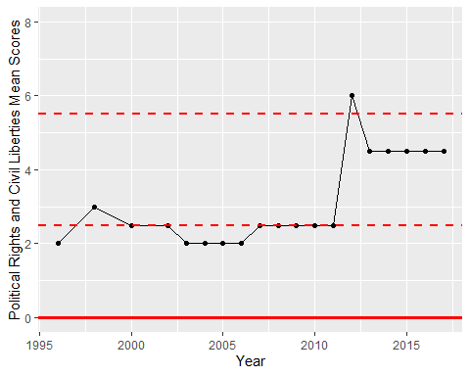

Freedom House Score Trend